EXCHANGE PROGRAM APPLICATION FORM (INCOMING)
SRING SEMESTER 2025/2026

Important Note: Please complete this form using PC. Upon completion of this form convert it to PDF format, print, sign and email with your application package.

SECTION A – PERSONAL DATA
1. Full Name (Please type in your first and last names as they appear on your travel document)
First Name(s) / Given Name(s)  Ilya | Last Name(s) / Surname  Polityko
2. Title | 3. Date of Birth
- Mr | (dd/mm/yyyy)  27/01/2006
4. Residential Address
Apt/Street  1st Tiraspolsky Lane, 3/ 43 | City/Town  Vitebsk | Zip/Postal Code  210027 | Country  Belarus
5. Home/Permanent Phone (if any) | 6. Mobile Phone
 | +375(33) 332-72-56
7. Email Address | 8. Telegram Alias (if any)
ilapolityko@gmail.com | @Kukrynitza
9. Nationality | 10. Citizenship
Belarus | Belarus
11. Special Needs (Do you have any special needs: sight or hearing disability, dyslexia or other health problems that may require the provision of special facilities in your living or studying environment?)
- No

12. Description (If your answer to question 11 is yes, please provide a description of your needs or required special arrangements)

SECTION B – EXCHANGE PROGRAMME DETAILS
13. Level of Study | 14. Current Semester
- Bachelor’s program | 4
15. Program of Study | 16. Expected Graduation Year
Data Science and Artificial Intelligence | (yyyy)  2027
17. Exchange Program Period
Spring semeter 2026

SECTION C – SENDING INSTITUTION
18. Name of Sending Institution | 19. Country
BSUIR | Belarus
20. Contact Person of Sending Institution  (Typically, from the International Relations Office) | 21. Email Address (Email address of contact person)
Pshonko E. S. | e.pshonko@bsuir.by
22. ECTS (Number of ECTS required by home institution)

SECTION D – PERSONAL CONTACT IN CASE OF EMERGENCY
23. Full Name of Contact Person | 24. Relationship
Anna Polityko | Mother
25. Full Address of Contact Person
Street/Apt  1st Tiraspolsky Lane, 3/ 43 | City/Town  Vitebsk
Zip/Postal Code  210027 | Country  Belarus
26. Home/Permanent Phone (if any) | 27. Mobile Phone
 | +375(29) 219-13-97

SECTION E – LANGUAGE REQUIREMENTS AND SKILLS

LANGUAGE REQUIREMENTS
28. Language Requirements (Please choose a certificate of language proficiency that you will attach to your application. The chosen certificate has to be not older than 2 years. For the courses taught in English, a B1 level of language proficiency is required. Applicable only if English is not your mother tongue.)
Type of the Certificate  Recommendation letter | Please specify, if chosen Other.

LANGUAGE SKILLS SELF-ASSESSMENT
29. Mother Tongue |  | 30. Language of Instruction at Home Institution
Russian |  | Please specify, if different from mother tongue.
31. English |  | 32. Russian
B2
33. Other Language 1 |  | 34. Other Language 2
Belarusian, Mother tongue

SECTION F – ACCOMMODATION
☑ YES, I would like to apply for on-campus accommodation once I receive a Letter of Acceptance from the International Relations Office of Innopolis University.

SECTION G – DECLARATION
(1) I hereby certify that all statements made are true and complete.
(2) I solemnly and sincerely declare that the documents submitted with the application are complete and correct. I understand that otherwise my admission to the selection process may be revoked.
(3) I fully understand that I am required to finance myself during the exchange period and that under current bilateral institutional agreements I am only granted a remission of the tuition fees at Innopolis University.
(4) I hereby certify that I have sufficient funds to cover all the necessary expenses, which include monthly living costs while studying abroad, obtaining visa(s)/residence permit(s), booking flights and accommodation and purchasing medical insurance.

Printed Name of Applicant Ilya Polityko……………………………….. Date (dd/mm/yyyy).......27/01/2006...................................

Signature of Applicant ……………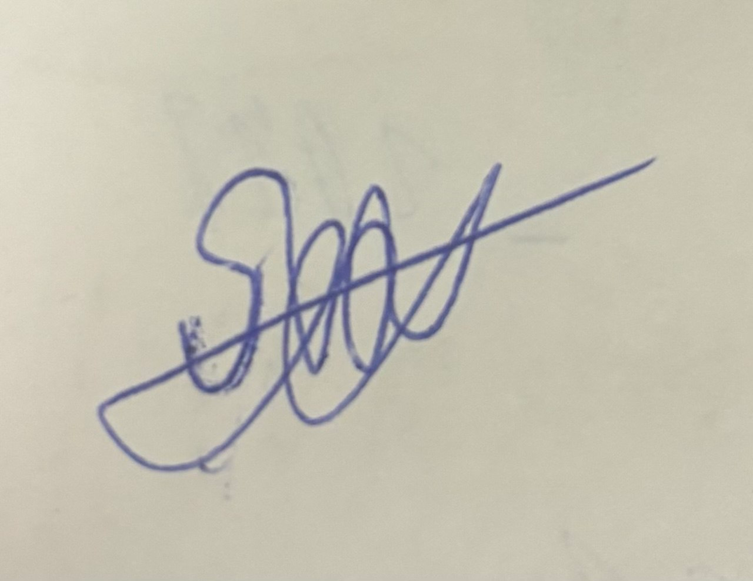………………………………………………………….

SECTION H – DOCUMENT CHECKLIST
REQUIRED ENCLOSURES

Please assemble all your documents as listed. Check each applicable item on the checklist and attach it to your email.
1. APPLICATION FORM (please check that the application form is completed, signed and dated) | ☑
2. RECENT DIGITAL PASSPORT PHOTO | ☑
3. COPY OF THE PERSONAL INFORMATION PAGE OF YOUR TRAVEL DOCUMENT | ☑
4. TRANSCRIPT OF RECORDS (of your completed semesters of study in English) | ☑
5. PRELIMINARY STUDY PLAN/LEARNING AGREEMENT | ☑
6. CURRENT CURRICULUM VITAE | ☑
7. MOTIVATION LETTER | ☑
8. PROOF OF LANGUAGE PROFICIENCY | ☑

OPTIONAL ENCLOSURES
* PROOF OF HEALTH INSURANCE valid in Russia (may be handed in after acceptance) | .

THANK YOU FOR COMPLETING THE FORM!

